Final project

Tautvydas Vedegys

SDA Academy

2020.06.21

**Content.**

1. **Document purpose 2p.**
2. **Testing section 2p.**
3. **Testing check list 3p.**
4. **Detailed test cases 4p.**
5. **Founded issues/bugs 5p.**
6. **Improvements 6p.**
7. **Test design techniques 7p.**
8. **Reflection 8p.**

**1.**

**1.Document purpose.**

To gain experience in testing and documenting, and improving my brother's website.

**2.Testing section.**

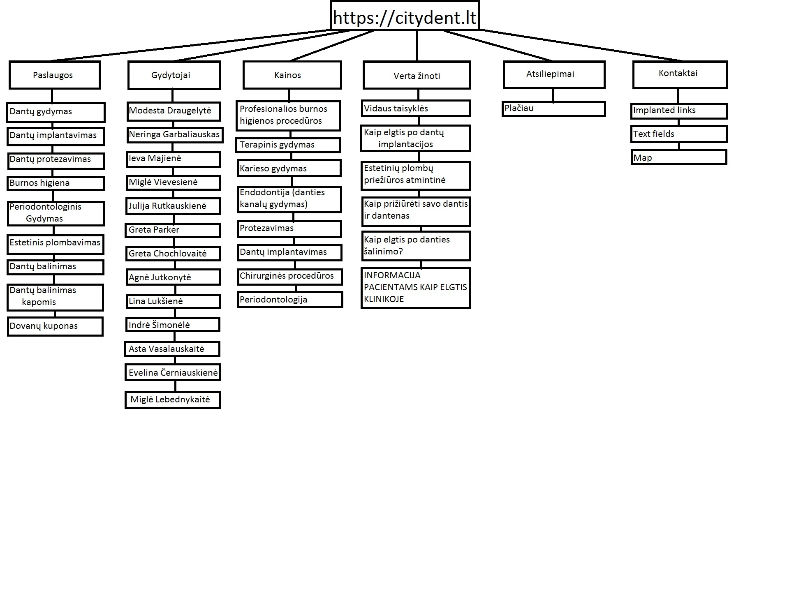

**2.**

**3. Testing check list.**

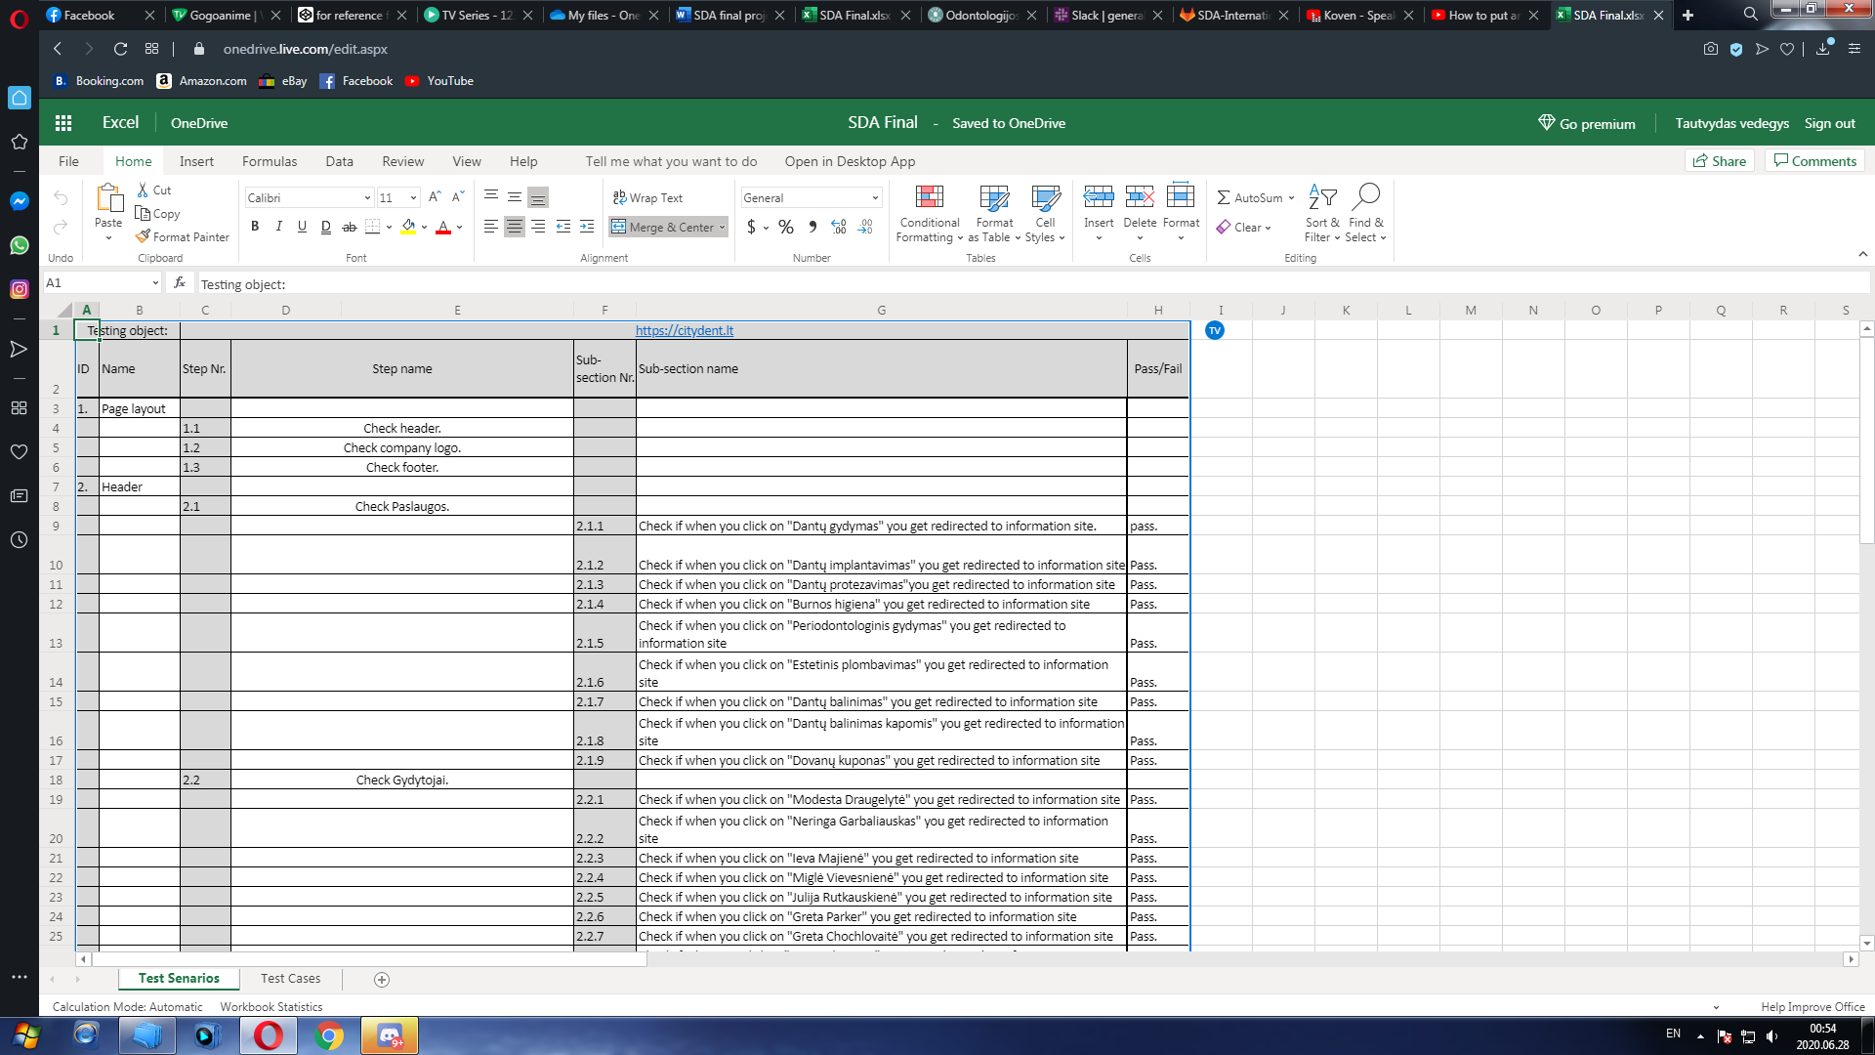

<https://1drv.ms/x/s!As1vfMR5yhiHhAyAayw5V4PADegG?e=Hs1lEc>

**3.**

**4.Detailed test cases**.

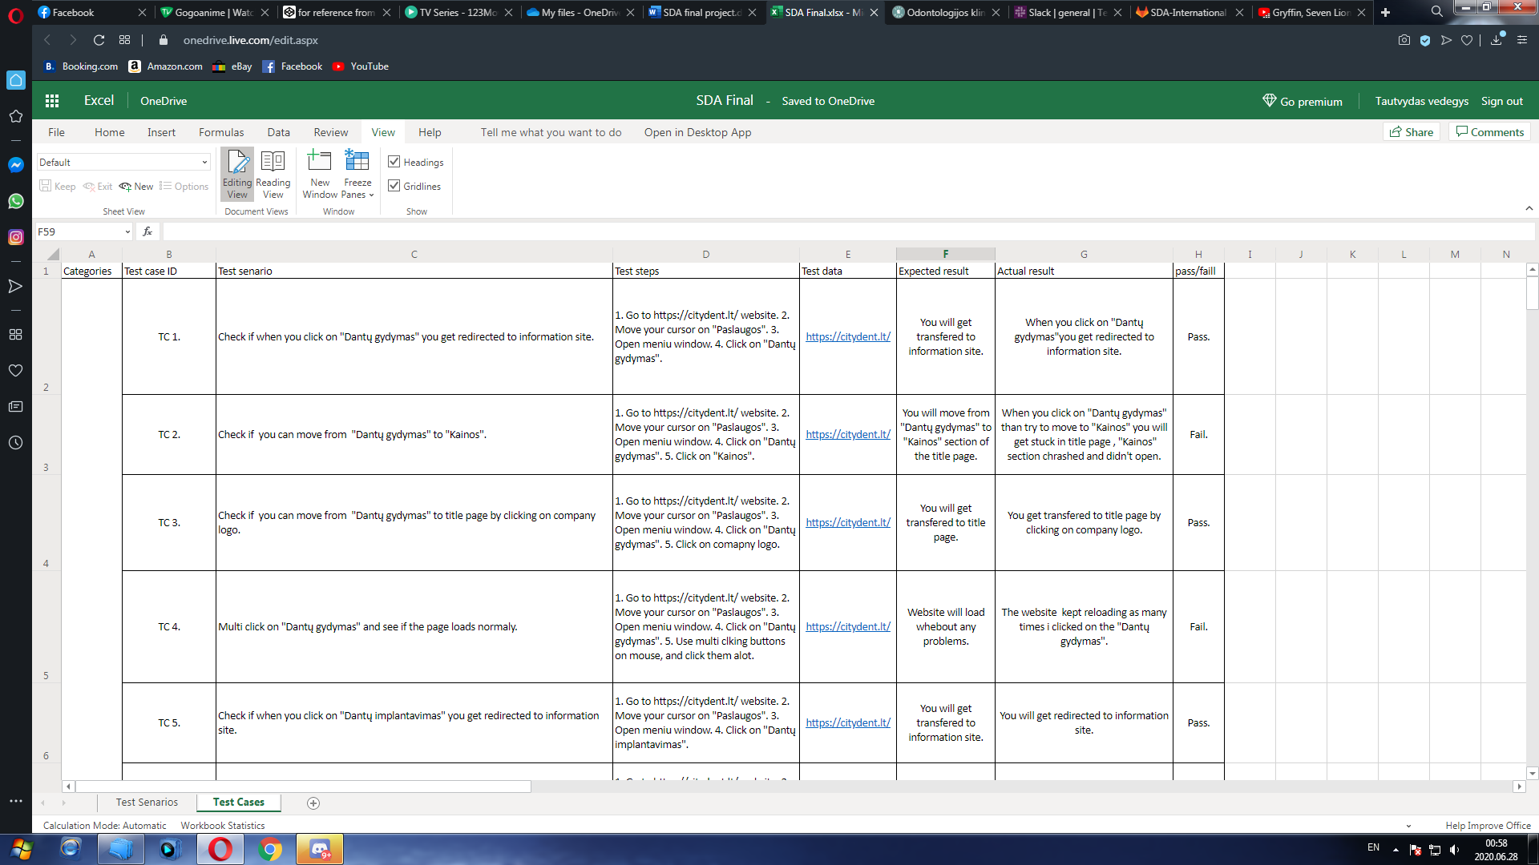

<https://1drv.ms/x/s!As1vfMR5yhiHhAyAayw5V4PADegG?e=Hs1lEc>

**4.**

**5. Founded issues/bugs**

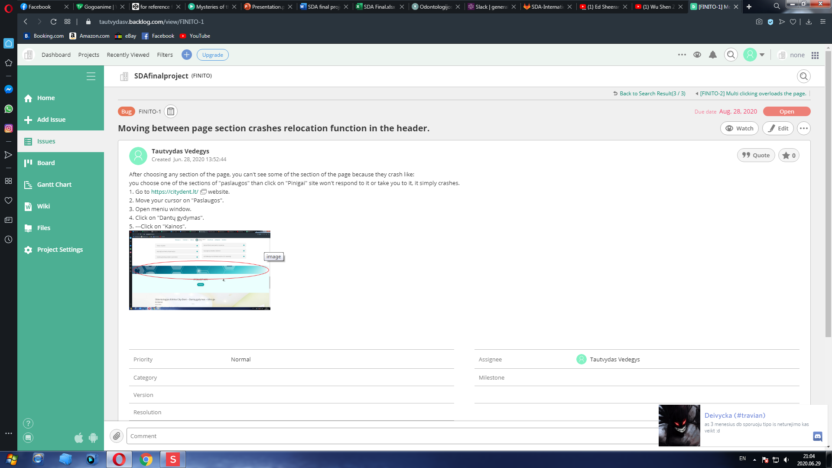

**5.**

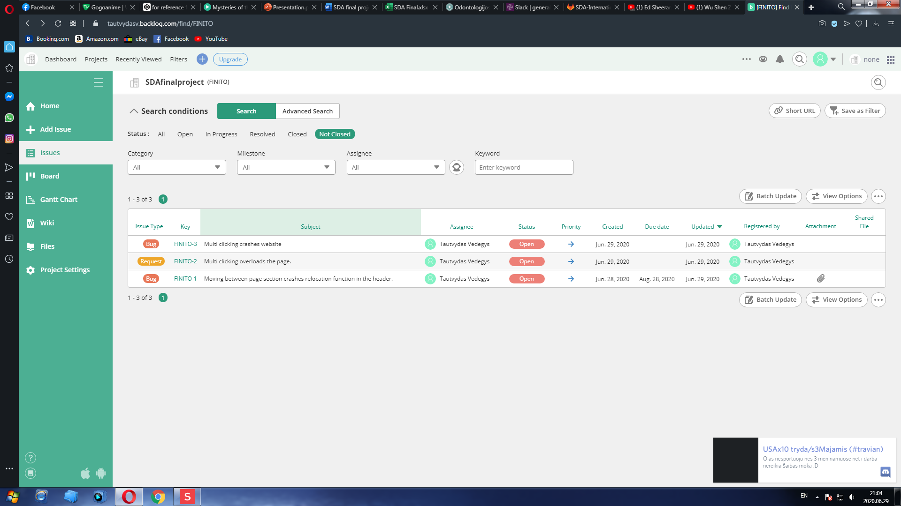**6. Improvements.**

1. **Implement registration form for clients, so they could register online.**
2. **ADD mouse lock function so website wouldn’t reload infinitely after accidental multi clicking.**
3. **Make website less strained, so it could load faster.**

**6.**

**7. Test design techniques.**

1. **Exploratory testing.**
2. **Boundary value analysis.**
3. **State transition testing.**
4. **Use case testing.**
5. **Check list based testing.**
6. **Equivalence partition testing.**

**7.**

**8. Reflection.**

I wrote test cases without any problem. I tested in 6 design’s since my chosen website wasn’t big, so I could check it all out, I found few bug’s, and came up with few improvement’s for this website. While I was testing I always was checking website code, to see what each function dose, and in that way I found what caused one of the bugs I found. I mainly did exploratory testing since I didn’t know what the website supposed to have and how it supposed to look, I didn’t have it’s document’s. I checked all the text field’s all of the implanted link’s and checked implanted map. I tested web-respons, and played a bit with it a little to see if website doesn't show any problems while it is in any size.

Hard part was that I had to do exploratory testing, since I didn’t see what the website supposed to have and how it supposed to look, I even tried error guessing that failed . The biggest problem is my lack of experience that one can only get by working in IT industry.

**8.**